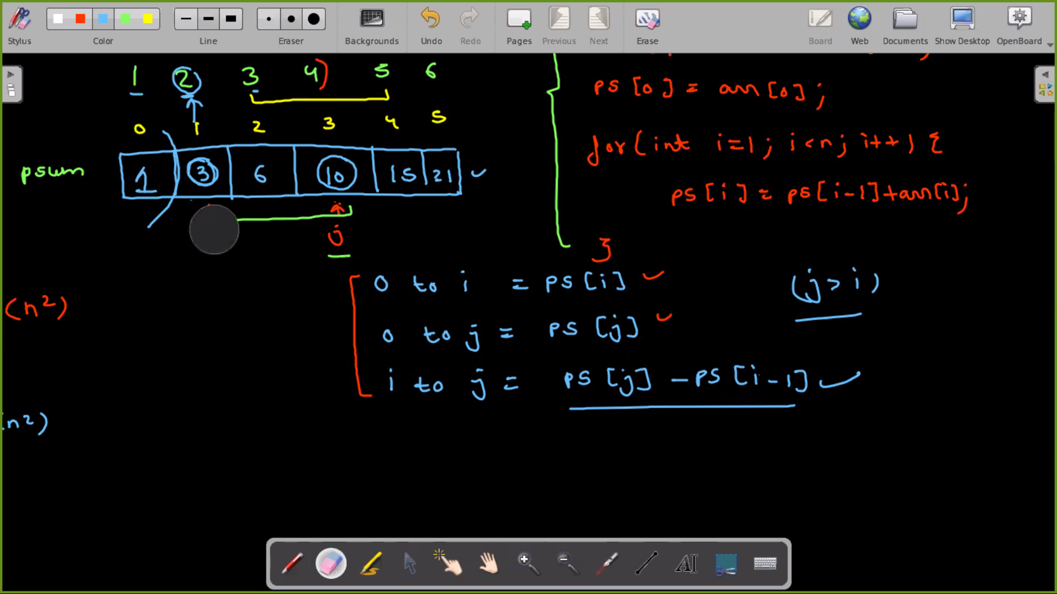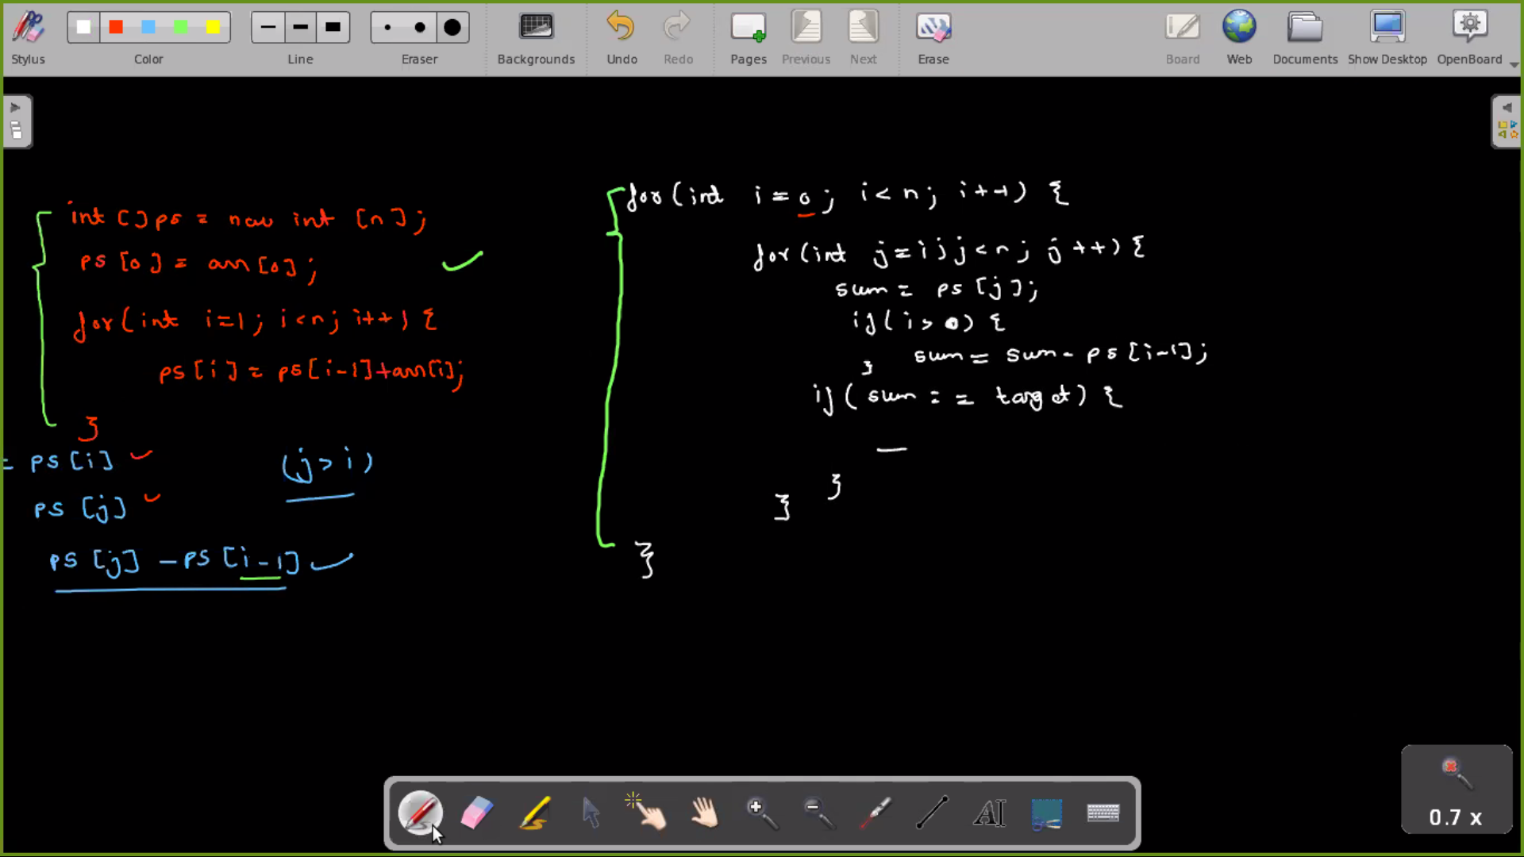import java.util.\*;

public class Main {

public static void main(String[] args) {

Scanner scn = new Scanner(System.in);

int n = scn.nextInt();

int i = 0;

int p = 1;

while(n > 0){

int dig = n % 10;

n = n / 10;

i += p \* Math.pow(10, dig - 1);

p++;

}

System.out.println(i);

}

}